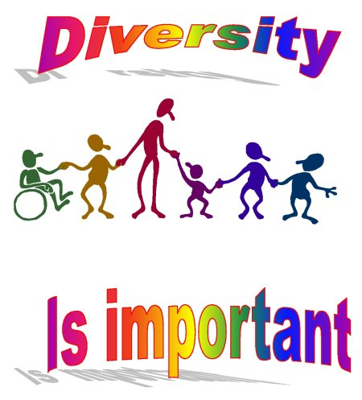
OPEN YOUR EYES!
Training course on intercultural diversity as a hidden
potential for inclusion

- Are you working with culturally diverse target groups?
- Or maybe you are afraid of involving such groups in your actions?
- Do you want to know what Cultural Diversity REALLY means?
- Would you like to recognize and to start to appreciate its potential?
- Or maybe you have plenty of outstanding experience that you would like to share with others?
- Are you searching for tools/methods that would help you to use potential of cultural diversity in your work?

If you answered for at least 3 questions YES → this training course is for you!

We would like to invite you for a 5 days training course organized by Hungarian National Agency of Youth in Action program that will take place and time in:

Győr, Hungary, 27th september –3rd October 2008

We are searching for participants that are:
- at least 18 years old
- have at least one youth exchange/international project experience (as coordinators or participants)
- have a communicative level of English
- work or would like to work with (culturally) diverse target groups
- are from programme countries

AIMS:
- To make youth work more inclusive and Culturally Diverse
- Decrease the fear and anxiety of risk to work with diverse target audience

Objectives:
- To provide participants with theoretical knowledge about CD → LOOK!
- To widen their personal perception of culture → OPEN YOUR EYES!
- to teach them how to use potential of cultural diversity in youth projects according to project structure (Preparation– Realization – Evaluation)→ SEE!
- To provide/work out the tools that would help in:
- working within Action 1.1
- including culturally diverse groups of young people
- to give them space to put their freshly – gained knowledge and skills more into action (future project planning) → PRACTICE!

Who pays what?
- Participants from Youth in Action programme country (27 EU countries + Norway, Iceland, Liechtenstein & Turkey) - the sending National Agency pays for their travel costs (and does the pre-selection)
- Programme costs, local travel (airport-venue), food and accommodation (in double rooms) are covered for all participants by the Hungarian NA for the duration of the training course

Please send your applications to the following email address: kepzes@mobilitas.hu and also to your National Agency of Youth in Action programme

Deadline of application: 15th July 2008
You will be informed of the results of the selection procedure by 31st July

For more information don`t hesitate to contact us.

your contact persons are:
From the trainers team:
- Ewa Niemiałkowska
- ewaniem@yahoo.com
- +48 507 425 598
- MSN: jezebel23@hotmail,

From the Hungarian National Agency:
- Csilla Szabo
- kepzes@mobilitas.hu
- +36-1-374-9066

Cultural diversity is like a box of chocolates, you never know what it is filled with…but after our training you will not be afraid of any flavor!!!

